

Course: Digital Literacy
Submitted by: Raina Gupta
Registration Number: 25BCE10822
Date of Submission: March 31 2026

- INDEX
- Task 1 – Digital Literacy Presentation
- Task 2 – Professional Online Portfolio
- Task 3 – Digital Platforms Usage
- Task 4 – Email Etiquette
- Task 5 – Cybercrime Case Study
- Learning Outcomes
- Conclusion

TASK 1 — DIGITAL LITERACY PRESENTATION

Objective of Task
The aim of this task was to create an awareness presentation to help students understand digital literacy and responsible internet usage.
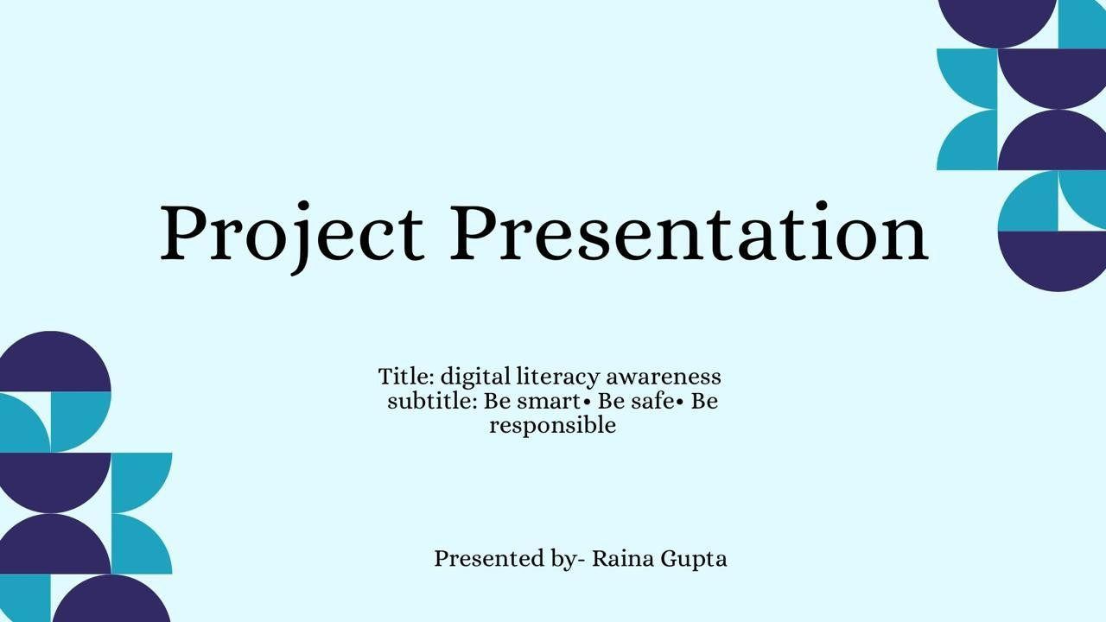

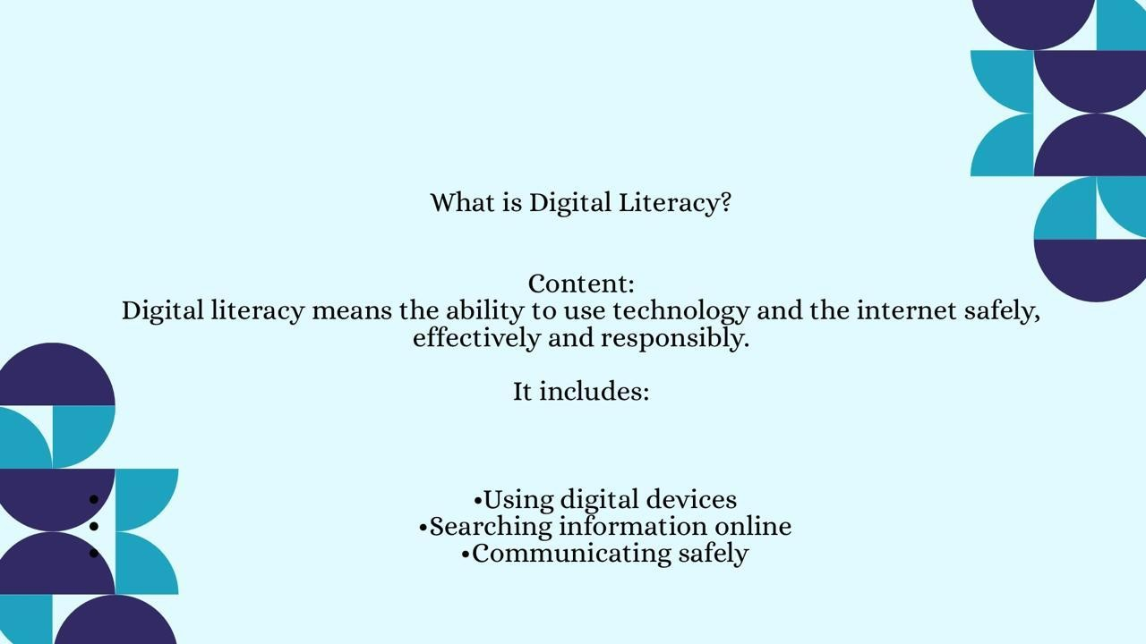

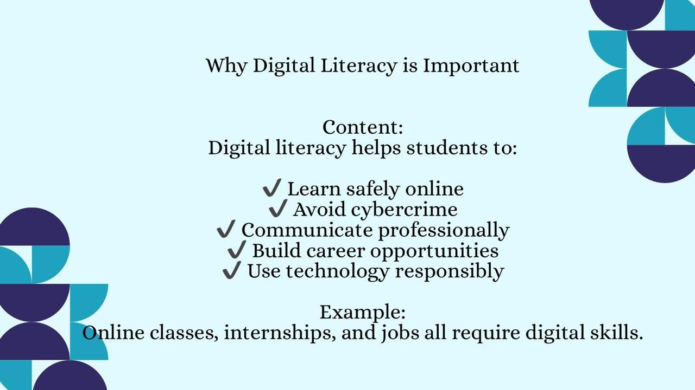
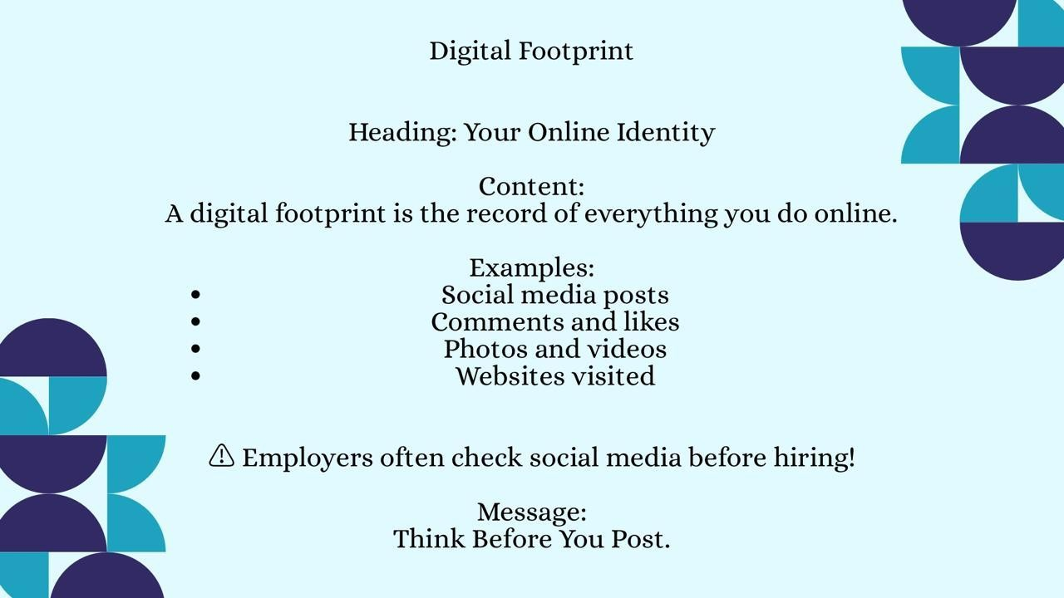

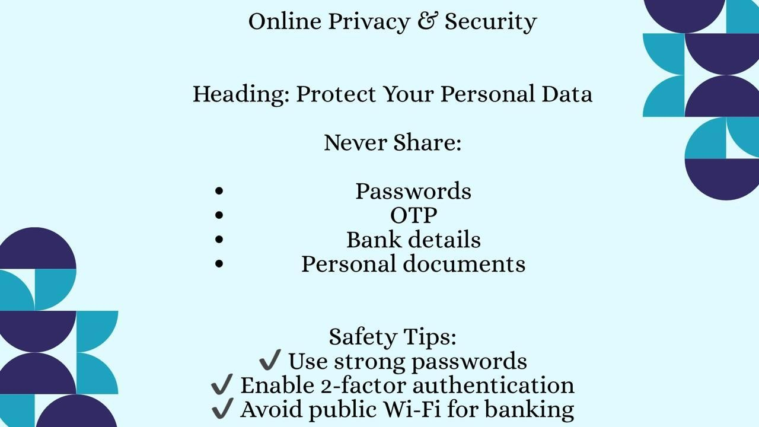
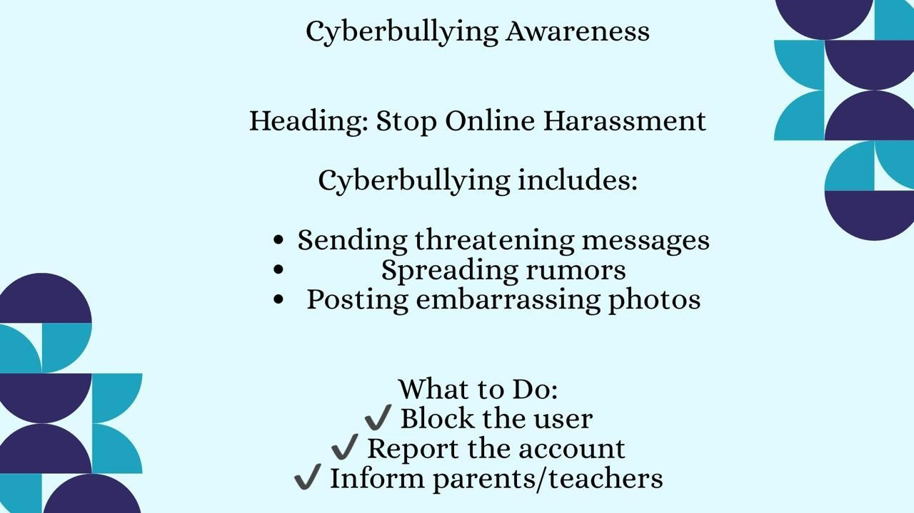

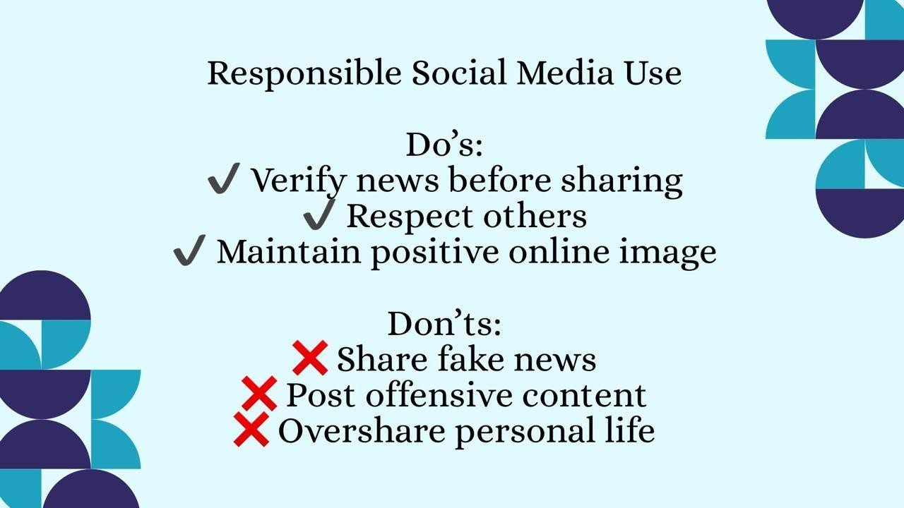
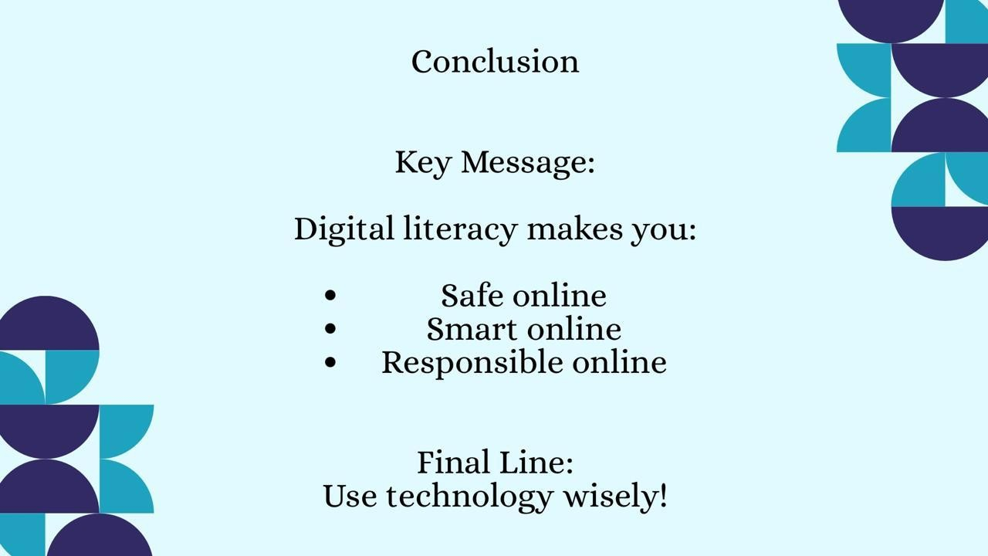

Tools Used
The presentation was designed using Canva to create visually appealing slides and spread awareness about digital literacy among students.

Creating this presentation helped me understand the importance of digital literacy and online safety. I learned how students can protect their personal data and behave responsibly on social media. This task also improved my research and presentation skills.

